**ICS** 67.180.20

**CCS X** 69



National Standard of the People's Republic of China

**GB/T 23528.3—2025**

|  |
| --- |
| **Replace GB/T 35545—2017** |

**Issue date：2025-04-25**

**Implementation date：2026-05-01**

**Issued by State Administration for Market Regulation**

**Standardization Administration of the People's Republic of China**

**Quality requirements for oligosaccharides —**

**Part 3: Xylo-oligosaccharides**

**低聚糖质量要求**

**第3部分：低聚木糖**

***(English Translation)***

**Foreword**

SAC/TC 64 is in charge of this English translation. In case of any doubt about the contents of English translation, the Chinese original shall be considered authoritative.

The document is drafted in accordance with the rules given in the GB/T 1.1—2020 *Directives for standardization—Part 1: Rules for the structure and drafting of standardizing documents*.

This document is one of the series of standards for *Quality requirements for oligosaccharides*. The following parts of this series of standards have been issued:

—— GB/T 35920 *General technical rules of oligosaccharides*;

—— GB/T 23528.2 *Quality requirements for oligosaccharides—Part 2: Fructooligosaccharide*;

—— GB/T 20881 *Isomaltooligosaccharide.*

This document replaces the GB/T 35545—2017 *Xylo-oligosaccharides* in whole, the following technical changes have been made with respect to the GB/T 35545—2017:

——Changing the scope of application (see Chapter 1, and Chapter 1 of the 2017 edition);

——Deleting the classification and requirements for the XOS-20 model (see 6.2 and 7.3 in the 2017 edition);

——Adding requirements for the auxiliary material maltodextrin (see 7.1);

——Changing the color requirements for syrup and sugar powder, as well as the appearance requirements for sugar powder (see 7.2, and 7.2 in the 2017 edition);

——Deleting hygiene requirements and corresponding test methods (see 7.4 and 8.9 in the 2017 edition)

——Changing the relevant requirements for sensory testing (see 8.2, and 8.1 in the 2017 edition)

——Changing the test methods for dry matter, transmittance, and pH (see 8.3, 8.6, 8.7, and 8.2, 8.5, 8.6 in the 2017 edition)

——Changing the test method for XOS content (see 8.8, Appendix A, B, and 8.7, Appendix A, B in the 2017 edition)

——Changing the inspection rules (see Chapter 9 and Chapter 9 in the 2017 edition);

——Changing the labeling, packaging, transportation, and storage (see Chapter 10, and Chapter 10 in the 2017 edition)

Attention is drawn to the possibility that some of the elements of this document may be the subject of patent rights. This issuing body of this document shall not be held responsible for identifying any or all such patent rights.

The document was proposed and prepared by SAC/TC 64 (National Technical Committee 64 on Food Industry of Standardization Administration of China).

The previous editions of this document are as follows:

——The first edition was issued in the 2017 as GB/T 35545—2017.

——This is the first revised edition.

**Introduction**

With the rapid development of fermentation industry, the variety of oligosaccharides is diversified, and the product quality has reached a new level, it has made great progress and progress from technology to category. The formulation of GB/T 23528 Quality requirements for oligosaccharides, enables the standardization and regulation of the quality and corresponding determination methods of oligosaccharides, it is the pre-requisite of standardizing the industrial order and promoting the development of oligosaccharides in food processing.

GB/T 23528 Quality requirements for oligosaccharides is intended to consist of the following four parts under the general title:

——*Part 1: General technical rules of oligosaccharides*. The purpose is to improve the product quality of the oligosaccharides industry.

——*Part 2:* *Fructooligosaccharide*. The purpose is to improve the product quality of the fructooligosaccharide industry.

——*Part 3:* *Xylo-oligoseccharides*. The purpose is to improve the product quality of the xylo-oligoseccharides industry.

——*Part 4: Isomaltooligoseccharide*. The purpose is to improve the product quality of the isomaltooligoseccharide industry.

Quality requirements for oligosaccharides—  
Part 3:Xylo-oligosaccharides

**1 Scope**

This document specifies the technical requirements, inspection rules, labeling, packaging, transportation, and storage requirements for xylo-oligosaccharides, describes the corresponding determination methods, provides information on molecular formula, structural formula, symbols, and product classification.

This document is applicable to the production, inspection and sale of xylo-oligosaccharides made from corn cob and/or corn stover as raw materials, using steam explosion or high-pressure cooking methods, enzymatic hydrolysis, and refining.

**2 Normative references**

The contents in the following documents constitute the essential clauses of this document through normative references in the text. For dated references, only the edition cited applies. For undated references, the latest edition of the referenced document (including any amendments) applies.

GB/T 191, *Packaging—Pictorial marking for handling of goods*

GB 5009.3—2016, *National food safety standard—Determination of moisture in foods*

GB 5009.4, *National food safety standard—Determination of ash in foods*

GB/T 6682, *Water for analytical laboratory use―Specification and test methods*

GB/T 20882.2, *Quality requirements for starch sugar―Part 2: Glucose syrup (powder)*

GB/T 20882.6, *Quality requirements for starch sugar―Part 6: Maltodextrin*

**3 Terms and definitions**

For the purposes of this document, the following terms and definitions apply.

3.1

Xylo-oligosaccharides; XOS

A mixture of oligosaccharides composed of 2 to 9 xylose units connected by *β*-1,4-glycosidic bonds.

**4** **Structural formula,** **molecular formula**

4.1 Structural formula

The structural formula of xylo-oligosaccharides is shown in Figure 1.

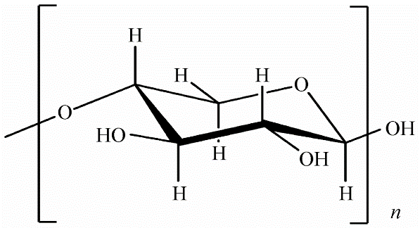

Figure 1 — Structural formula of xylo-oligosaccharides

4.2 Molecular formula

C5n H8n+2 O4n+1 ,2≤n≤9.

**5 Symbol**

The symbols and representative names are shown in Table 1.

**Table 1 —** S**ymbols and representative names**

|  |  |
| --- | --- |
| Symbol | Representative name |
| XOS | Xylo-oligosaccharides |
| XOS2-4 | Total of xylobiose, xylotriose and xylotetraose |
| X2 | Xylobiose |
| X3 | Xylotriose |
| X4 | Xylotetraose |
| X5 | Xylpentaose |
| X6 | Xylohexaose |
| X7 | Xyloheptaose, Xylooctaose and Xylononaose |

**6 Product classification**

6.1 Divided into the following two categories based on product form:

——Syrup (L type);

——Sugar powder (P type).

6.2 Divided into the following three categories based on XOS content:

——XOS-95 type;

——XOS-70 type;

——XOS-35 type.

**7 Requirements**

7.1 Requirements for raw and auxiliary materials

7.1.1 Maltodextrin

It shall comply with the provisions of GB/T20882.6.

7.1.2 Requirements for other raw and auxiliary materials

It shall comply with corresponding standards or relevant regulations.

7.2 Sensory indicators

Indicators shall comply with the specifications in Table 2.

**Table 2 — Sensory indicators**

|  |  |  |
| --- | --- | --- |
| Items | Syrup (L type) | Sugar powder (P type) |
| State | Viscous transparent liquid | Powder or granule |
| Color | Colorless to yellow | White to slightly light yellow |
| Odour | Unique odor of this product, without abnormal odor | |
| Taste | Sweet taste | |
| Impurity | No visible impurities | |

7.3 Physicochemical indicators

Indicators shall comply with the specifications in Table 3.

**Table 3 — Physicochemical indicators**

|  |  |  |  |  |  |
| --- | --- | --- | --- | --- | --- |
| Items | XOS-95 type | | XOS-70 type | | XOS-35 type |
| Sugar powder (P type) | Syrup (L type) | Sugar powder (P type) | Syrup (L type) | Sugar powder (P type) |
| Dry matter (solids)/% | — | ≥70 | — | ≥70 | — |
| Moisture/% | ≤5.0 | — | ≤5.0 | — | ≤6.0 |
| Ash/% | ≤0.3 | ≤0.3 | ≤0.3 | ≤0.3 | ≤0.3 |
| Transparency/% | — | ≥70 | — | ≥70 | — |
| pH | 3.5-6.0 | | | | |
| Content of XOS (calculated on dry basis) /(g/100g) | ≥95.0 | ≥95.0 | ≥70.0 | ≥70.0 | ≥35.0 |
| Content of XOS2-4 (calculated on dry basis) /(g/100g) | ≥65.0 | ≥65.0 | ≥50.0 | ≥50.0 | — |

**8 Determination methods**

8.1 General requirements

In this method, the reagents used refer to analytical reagent when no other specifications are indicated; The water shall comply with the water specification above class III (including class III) in GB/T6682.

8.2 Sensory inspection

8.2.1 State, color and impurity

Take about 50g or 50mL of the sample in a colorless and clean sample cup (or 200mL beaker). Under natural light, visually observe the state, color and impurities of the sample, and make records.

8.2.2 Odor

Take about 20g or 20mL of the sample, put it into a 250mL conical flask with a stopper, add 50mL of water at 80 ℃, cover and shake it for 30s, smell the odor, and make records.

8.2.3 Taste

After rinsing with water, take a small amount of sample into your mouth, taste it carefully, and make records.

8.3 Dry matter (solids)

It shall be determined according to the method specified in GB/T20882.2.

8.4 Moisture

Determine according to the method specified in the first direct drying method in GB5009.3-2016, weigh 2g-3g of the sample, accurately weigh it, place it in a 100℃-101℃ drying oven, and dry it for 4h until constant weight.

8.5 Ash

It shall be determined according to the method specified in GB5009.4.

8.6 Transmittance

It shall be determined according to the method specified in GB/T20882.2. When measuring, set the measuring wavelength to 420nm.

8.7 pH

It shall be determined according to the method specified in GB/T20882.2. For the sugar powder sample, weigh about 20g of the sample, accurate to 0.1g, add 40mL of CO*2* free water with pH of 5.0-7.0, and other operations remain unchanged. The syrup sample shall be prepared into the solution to be tested containing 10% dry matter (solids), and other operations remain unchanged.

8.8 Content of XOS

Both Appendix A and B methods can be used for testing, with Appendix B being the arbitration method.

The chromatogram of sample solution M*2* after hydrolysis of XOS-70 type syrup is shown in Figure C.2 in Appendix C;

The chromatogram of the sample solution KS-802 after XOS-70 type sugar powder enzymatic hydrolysis and alcohol precipitation is shown in Figure C.3;

The chromatogram of the sample solution KS-802 after XOS-35 type sugar powder enzymatic hydrolysis and alcohol precipitation is shown in Figure C.4;

8.9 Content of XOS2-4

Determine according to the method specified in Appendix A.

**9 Inspection rules**

9.1 Batching and Sampling

9.1.1 Batching

The products which are produced continuously with the same raw materials, same process on the same production line and are of quality consistence shall be considered as one batch.

9.1.2 Sampling

9.1.2.1 take samples according to table 4.

**Table 4 — Product sampling**

|  |  |
| --- | --- |
| Batch size range / Minimum external package unit | Number of the drawn samples / Minimum external package unit |
| ＜100 | 2 |
| 100-500 | 4 |
| ＞500 | 6 |
| Note: the minimum outer packaging unit refers to the minimum sales unit. | |

9.1.2.2 Take the samples and divide them into two portions, seal, and label. The labeling shall include product name, sampling time, batch number, and name of the sampler. One portion is for testing, and the other is for storage. Keep it for half a month for future reference. The sampling quantity for each batch should be two or three times the amount required for a full-range inspection, and the total quantity shall be no less than 1000g.

9.2 Delivery inspection

9.2.1 Before products are released from the factory, they shall be inspected batch by batch to ensure to meet the requirements in this document.

9.2.2 Inspection items of syrup products for delivery: sensory requirements, dry matter (solids), transmittance, pH, XOS content, XOS2-4 content and ash.

9.2.3 Inspection items of sugar powder products for delivery: sensory requirements, moisture, pH, XOS content, XOS2-4 content and ash.

9.3 Type inspection

Inspection items are all the items required in this document. In general, the type inspection on the same kind of products shall be conducted once every six months. In any of the following cases, it is also necessary to conduct the inspection:

——Before the new product is put into production;

——Significant difference in the delivery inspection result from the last type examination results;

——When replacing equipment, main raw and auxiliary materials or changing key processes may affect product quality;

——When production is recovered after production is stopped for half a year or more;

——When the national supervision institution puts forward the requirements for type inspection.

9.4 Judgment rules

9.4.1 Take the samples for inspection, if all inspection items meet the requirements, the batch product is judged to be in compliance with this document.

9.4.2 If the results of one to two items do not meet the requirements, twice the amount of samples from the same batch shall be inspected again, and the re-inspection results shall prevail. If there is still one item that does not meet the requirements, the batch of product is judged as non-compliant with this document. If there are three or more items that do not meet the requirements, the batch of product is judged as non-compliant with this document.

**10 Labeling, packaging, transportation and storage**

10.1 Labeling

The packaging pictorial markings for handling of goods shall comply with the requirements of *GB/T191* and shall mark the product classification.

10.2 Packaging

10.2.1 Syrup products: the packaging container shall be clean, sanitary and undamaged.

10.2.2 Sugar powder products: the inner packaging is made of polyethylene plastic or aluminum foil, as well as other packaging materials that meet the food requirements; The outer packaging shall be made of paper plastic composite bags or cardboard barrels. The packaging shall be solid, the labels shall be clear and tidy, and the bag mouth shall be sealed to ensure no leakage during loading, unloading, transportation and storage. Or choose packaging according to customer requirements.

10.3 Transportation

10.3.1 The product transportation tools shall be clean and pollution-free, and the products shall be protected from the sun and rain during transportation and shall not be loaded and transported together with toxic, harmful, odorous or affecting the product quality.

10.3.2 Handle with care and do not throw, impact or squeeze.

10.4 Storage

10.4.1 Storage shall be in a ventilated, dry and clean warehouse, strictly protected from sun, rain and fire; any kindling material is prohibited.

10.4.2 Storage shall be protected from toxic, hazardous, corrosive, and abnormal odor articles.

Annex A

(Normative)

Method for determination of xylo-oligosaccharides content - High performance liquid chromatography

A.1 Principle

The components that enter the chromatographic column at the same time are repeatedly distributed between the two phases of the chromatographic column with the mobile phase due to the different dissolution, adsorption, permeation or ion exchange between the mobile phase and the stationary phase. Due to the different moving speed of the components in the chromatographic column, they separate from each other after passing through a certain length of chromatographic column, flow out of the chromatographic column in sequence, enter the signal detector, display the spectral peak value of each component on the recorder or data device, compare and determine the quality according to the retention time, and calculate the content of various sugar components according to the peak area with xylose as the reference.

A.2 Reagents and materials

Unless otherwise specified, use only analytically pure reagents.

A.2.1 Reagents

A.2.1.1 Compound glucoamylase: glucoamylase activity≥100000 U/mL, pullulanase activity≥1000U/mL

A.2.1.2 Anhydrous ethanol (C2H5OH): analytically pure.

A.2.1.3 Water: class I water specified in GB/T6682.

A.2.2 Standard sample/standard material

A.2.2.1 D-xylose standard sample/standard material: CAS No. 58-86-6, purity≥99.0%.

A.2.2.2 Xylobiose standard sample/standard material: CAS No. 6860-47-5, purity≥95.0%.

A.2.2.3 Xylotriose standard sample/standard material: CAS No. 47592-59-6, purity≥95.0%.

A.2.2.4 Xylotetraose standard sample/standard material: CAS No. 22416-58-6, purity≥95.0%.

A.2.2.5 Xylpentaose standard sample/standard material: CAS No. 49694-20-4, purity≥95.0%.

A.2.2.6 Xylohexaose standard sample/standard material: CAS No. 49694-21-5, purity≥95.0%.

A.2.2.7 Glucose standard sample/standard material: CAS No. 50-99-7, purity≥99.0%.

A.2.2.8 L-arabinose standard sample/standard material: CAS No. 5328-37-0, purity≥99.0%.

A.2.3 Preparation of standard solution

A.2.3.1 Xylose standard solution (2mg/mL): weigh 0.1000g of D-xylose standard sample/standard material, put it into a 50mL volumetric flask, and dissolve it with water to constant volume.

A.2.3.2 Xylobiose, xylotriose, xylotetraose, xylpentaose and xylohexaose standard solutions (1mg/mL): weigh 0.0050g of each standard sample/standard material respectively, put them in a 5mL volumetric flask, and dissolve them with water to the scale.

A.2.3.3 Glucose and L-arabinose standard solution (2mg/mL): weigh 0.1000g of each standard sample/standard material respectively into a 50mL volumetric flask, and dissolve with water to volume to the scale.

A.3 Instrument and equipment

Laboratory conventional instruments, equipment and the following items:

a) High performance liquid chromatograph: equipped with differential refraction detector and column temperature box;

b) Filter membrane: 0.45μm microporous water phase filter membrane;

c) Balance: precisions are 0.1mg;

d) Thermostatic water bath.

A.4 Reference chromatographic condition

A.4.1 Chromatographic column: cationic gel column (sodium sulfonated styrene divinylbenzene copolymer resin gel ϕ8mm × 300mm 6μm, exclusion limit 10000), or chromatographic column with equivalent performance.

A.4.2 Mobile phase: Grade I water in GB/T6682.

A.4.3 Flow rate: 0.6mL/min.

A.4.4 Column temperature: 80℃.

A.4.5 Differential detector temperature: 45℃.

A.4.6 Injection volume: 20μL.

A.5 Analysis procedures

A.5.1 Sample solution preparation

A.5.1.1 XOS-70L/95L/95P/70P (without maltodextrin) sample: weigh about 0.5g (accurate to 0.001g) sample, add water to volume to 50mL, shake well, pass through 0.45μm microporous aqueous phase filter membrane, and wait for machine testing.

A.5.1.2 XOS-70P/35P (containing maltodextrin) sample: weigh 0.5g-1.0g (accurate to 0.001g) sample, put it into a 50mL small beaker, add 20.0mL water and 40μL compound glucoamylase (A.2.1.1) in a water bath pot for enzymatic hydrolysis at 60℃ for 30min, take out, transfer them into a 50mL volumetric flask, add 7.0mL-10.0mL water, wash the beaker twice, fix the volume with anhydrous ethanol (A.2.1.2), and shake well. Stand for separation, take 5.0mL of the supernatant, evaporate it to dryness at 80℃ in a small beaker, add 5.0mL of water to dissolve the sample, shake it well, and pass it through a 0.45μm microporous aqueous phase filter membrane, to be tested on the machine.

A.5.2 Determination of standard solution

Take 20μL of standard solution (A.2.3.1-A.2.3.3) and inject them into the liquid chromatograph respectively and record the corresponding chromatographic peak retention time and peak area.

A.5.3 Determination of sample solution

Take 20μL of the sample solution and inject it into the liquid chromatograph to determine the retention time. The retention time of xyloheptaose (including Xylooctaose and

Xylononaose) is 0.707 times that of xylose. Calculate the content of various sugar components by peak area external standard method.

The chromatogram of KS-802 of sample solution after XOS-70 type sugar powder enzymatic hydrolysis + alcohol precipitation is shown in Figure C.3;

The chromatogram of KS-802 of sample solution after XOS-35 type sugar powder enzymatic hydrolysis + alcohol precipitation is shown in Figure C.4.

A.5.4 Expression of analysis results

The content of each component in the sample shall be calculated by comparing its peak area with that of the xylose standard solution of known concentration, and then applying the corresponding correction factor.

The XOS content in the sample is calculated according to formula (A.1):

$XOS=\frac{\left[A_{2}×F_{1}+\left(A_{3}+A_{4}+A_{5}+A_{6}+A_{7}\right)×F_{2}\right]×ρ×V}{A_{1}×m×1000}×100$………………………………………………（A.1）

The XOS2-4 content in the sample is calculated according to formula (A.2):

${XOS}_{2−4}=\frac{\left[A_{2}×F_{1}+\left(A_{3}+A_{4}\right)×F_{2}\right]×ρ×V}{A_{1}×m×1000}×100$……………………………………………………（A.2）

where:

XOS ——content of xylo-oligosaccharides in the sample, unit: grams per hundred grams (g/100g);

XOS2-4 ——the content of xylo-oligosaccharides (xylobiose - xylotetraose) in the sample, unit: grams per hundred grams (g/100g);

A1  ——xylose peak area in xylose standard chromatogram;

A2  ——xylobiose peak area in the chromatogram of the sample;

A3  ——xylotriose peak area in the chromatogram of the sample;

A4  ——xylotetraose peak area in the chromatogram of the sample;

A5  ——xylpentose peak area in the chromatogram of the sample;

A6  ——xylohexaose peak area in the chromatogram of the sample;

A7  ——The sum of peak areas of xyloheptaose, Xylooctaose and Xylononaose in the chromatogram of the sample;

F1  ——correction factor for XOS2 is 0.93;

F2  ——correction factor for XOS3 and above sugars is 0.94;

ρ ——mass concentration of xylose standard solution, unit: milligram per milliliter (mg/mL);

V ——total volume of dissolved sample, unit: milliliter (mL);

m ——weigh the mass of the sample (on a dry basis), unit: grams (g).

The calculation result is kept to one decimal place.

A.6 Precision

The absolute difference between the two independent determination results obtained under the repeatability condition shall not exceed 5% of the arithmetic mean.

Annex B

(Normative)

Method for determination of xylo-oligosaccharides content - Dilute acid hydrolysis high performance liquid chromatography

B.1 Principle

The sample was subjected to acid hydrolysis to hydrolyze xylo-oligosaccharides into monosaccharides, which were separated and quantitatively determined by high performance liquid chromatography. The content of xylo-oligosaccharides in the sample is the product of the difference of xylose content before and after hydrolysis of the sample and the average conversion coefficient of xylo-oligosaccharides and xylose.

B.2 Reagents and materials

Unless otherwise specified, use only analytically pure reagents.

B.2.1 Reagents

B.2.1.1 4.0mol/L sulfuric acid solution: take a 250mL volumetric flask, measure 150mL of water and add it to the volumetric flask, then take 55mL of 98% sulfuric acid (high-grade pure), slowly put it along the inner wall of the volumetric flask, mix it with a glass rod while adding it, be careful to prevent splashing, add water to the scale after cooling, and shake the cap evenly for standby.

B.2.1.2 0.005mol/L sulfuric acid solution: weigh 1.000g of sulfuric acid solution (B.2.1.1) and dilute to 2L with water.

B.2.1.3 Water: class I water specified in *GB/T6682*.

B.2.2 Standard sample/standard material

B.2.2.1 D-xylose standard sample/standard material: CAS No. 58-86-6, purity≥99.0%.

B.2.2.2 Glucose standard sample/standard material: CAS No. 50-99-7, purity≥99.0%.

B.2.2.3 L-arabinose standard sample/standard material: CAS No. 5328-37-0, purity≥99.0%.

B.2.3 Preparation of standard solution

B.2.3.1 Xylose standard stock solution (5.0mg/mL): accurately weigh 0.1250g of D-xylose standard sample/standard material into a 25mL volumetric flask, and dissolve it with water to constant volume.

B.2.3.2 L-arabinose standard stock solution (2.0mg/mL): accurately weigh 0.0500g of L-arabinose standard sample/standard material into a 25mL volumetric flask, and dissolve it with water to constant volume.

B.2.3.3 Glucose standard stock solution (10.0mg/mL): accurately weigh 0.2500g of glucose standard sample/standard material into a 25mL volumetric flask, and dissolve with water to volume.

B.2.4 Preparation of standard working fluid.

The preparation of standard working fluid is shown in Table B.1.

**Table B.1 — Preparation of standard working fluid**

|  |  |  |  |  |  |
| --- | --- | --- | --- | --- | --- |
| No. | Xylose standard stock solution volume/mL | L-arabinose standard stock solution volume/mL | Glucose standard stock solution volume/mL | Fixed volume/mL | Mass concentration of xylose standard working solution/(mg/mL) |
| 1 | 0.5 | 0.25 | 0.1 | 10 | 0.25 |
| 2 | 1.0 | 0.5 | 0.2 | 10 | 0.5 |
| 3 | 1.5 | 1.0 | 0.5 | 10 | 1.0 |
| 4 | 2.0 | 1.5 | 1.0 | 10 | 1.5 |
| 5 | 2.5 | 2.0 | 1.5 | 10 | 2.0 |
| 6 | 3.0 | 2.5 | 2.0 | 10 | 2.5 |

B.3 Instrument and equipment

Laboratory conventional instruments, equipment and the following items:

a) High performance liquid chromatograph: equipped with differential refraction detector and column temperature box;

b) Balance: sensitivity 0.1mg;

c) Thermostatic water bath;

d) 0.22μm microporous water phase membrane.

B.4 Reference chromatographic condition

B.4.1 Chromatographic column: cationic gel column (hydrogen sulfonated styrene divinylbenzene copolymer resin gel Φ8mm×300mm 9μm, exclusion limit 1000), or chromatographic column with equivalent performance.

B.4.2 Injection volume: 20μL.

B.4.3 Mobile phase:

B.4.4 Flow rate: 0.6mL/min.

B.4.5 Column temperature: 60℃.

B.4.6 Differential detector temperature: 45℃.

B.5 Analysis procedures

B.5.1 Sample solution preparation

B.5.1.1 Preparation of sample solution M1 before hydrolysis: weigh 1g-2g of sample (2g for XOS content of 70% and below), accurate to 0.0001g, dissolve with 0.005mol/L sulfuric acid solution (B.2.1.2) and dilute to 100mL, shake well, take the solution and filter it with 0.22μm microporous aqueous phase filter membrane, and then determine it on the machine. The total diluted volume of sample treatment solution M1 before hydrolysis V1=100mL.

B.5.1.2 Preparation of sample solution M2 after hydrolysis: take 10mL of sample solution M1 before hydrolysis into a 100mL colorimetric tube, add 1.2mL of 4.0mol/L sulfuric acid solution (B.2.1.1), shake well, hydrolyze in a boiling water bath for 100min, take out, cool, dilute to 100mL scale, and shake well. Filter with 0.22μm microporous water phase filter membrane, and measure on the machine. The total diluted volume of sample treatment solution M2 after hydrolysis V2=1000mL. The chromatogram of sample solution M2 after hydrolysis of XOS-70 syrup is shown in Figure C.2.

B.5.2 Making standard curve

Take 20μL of standard working solution (B.2.4) for analysis by high performance liquid chromatography. Make a standard curve with xylose peak area against xylose concentration, and the linear correlation coefficient should be above 0.9990.

The mixed chromatogram of glucose, xylose and L-arabinose is shown in figure C.1.

B.5.3 Sample solution preparation

Take 20μL of sample treatment solution M1 and M2, respectively, and inject them into the high- performance liquid chromatography for separation. Qualitative analysis was carried out based on the retention time of each monosaccharide component peak. The xylose mass concentrations ρ1 and ρ2 were obtained from the standard curve or regression calculation based on the peak area for calculation.

B.5.4 Expression of analysis results

The XOS content in the sample is calculated according to formula (B.1)- (B.3):

${M_{1}=ρ}_{1}×\frac{V_{1}}{W}×{10}^{−3}×100$………………………………………………（B.1）

${M_{2}=ρ}_{2}×\frac{V_{2}}{W}×{10}^{−3}×100$………………………………………………（B.1）

$XOS=\left(M_{2}−M_{1}\right)×1.1$………………………………………………（B.3）

where:

M1 ——Xylose content before sample hydrolysis, grams per hundred grams (g/100g);

M2 ——Xylose content after sample hydrolysis, grams per hundred grams (g/100g);

XOS ——content of xylo-oligosaccharides in the sample, grams per hundred grams (g/100g);

ρ1 ——Mass concentration of xylose component in sample treatment solution before hydrolysis, unit: milligrams per milliliter (mg/mL);

ρ2 ——Mass concentration of xylose component in sample treatment solution after hydrolysis, unit: milligrams per milliliter (mg/mL);

V1 ——Total diluted volume of sample treatment solution before hydrolysis, unit: milliliters (mL);

V2 ——Total diluted volume of sample treatment solution after hydrolysis, unit: milliliters (mL);

W ——mass of the sample (on a dry basis), unit: grams (g);

1.1 ——Average correction factors for xylo-oligosaccharides and xylose.

The calculation result is kept to one decimal place.

B.6 Precision

The absolute difference between the two independent determination results obtained under the repeatability condition shall not exceed 5% of the arithmetic mean.

Annex C

(Informative)

Typical differential detection chromatogram of oligosaccharides detected by high-performance liquid chromatography

**C.1**

The mixed chromatogram of glucose, xylose and arabinose is shown in figure C.1, and the chromatographic conditions are shown in B.4.

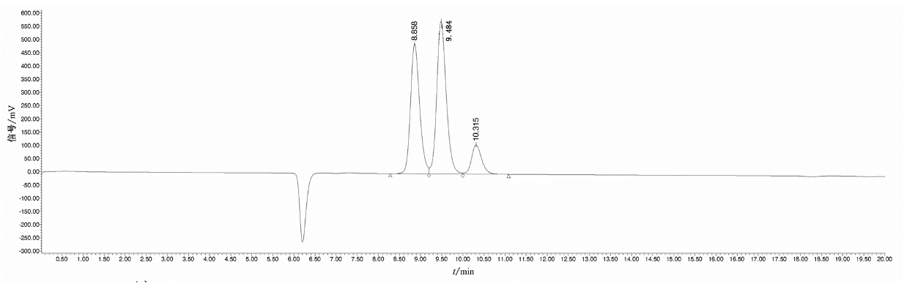

Note: 8.858min is glucose, 9.484min is D-xylose, 10.315min is L-arabinose.

**Figure C.1 Chromatogram of standard working solution (No.2)**

**C.2**

The chromatogram of sample solution M2 after hydrolysis of XOS-70 syrup is shown in Figure C.2, and the chromatographic conditions are shown in B.4.

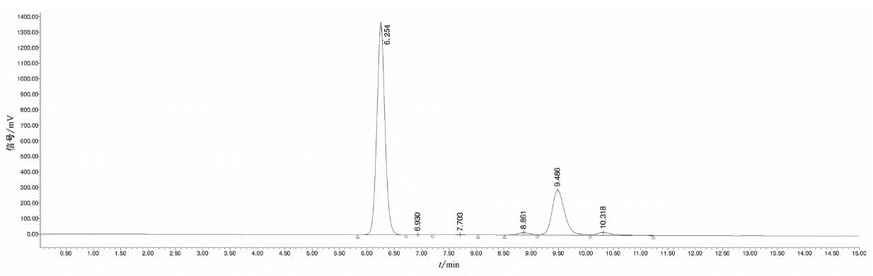

Note: 8.861min is glucose, 9.486min is D-xylose, 10.318min is L-arabinose.

**Figure C.2 —Chromatogram of sample solution M2 after hydrolysis of XOS-70 syrup**

**C.3**

The chromatogram of KS-802 sample solution after XOS-70 sugar powder enzymatic hydrolysis + alcohol precipitation is shown in Figure C.3, and the chromatographic conditions are shown in A.4.

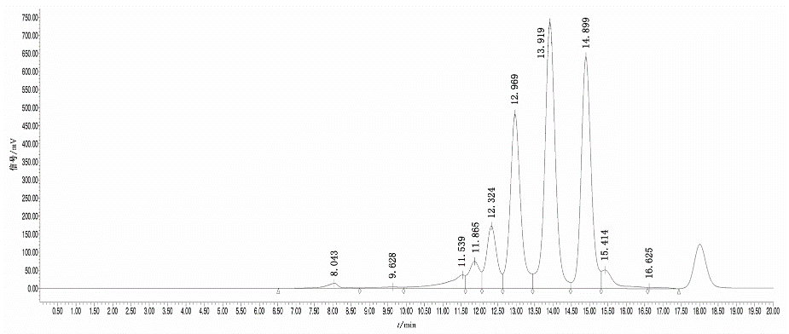

Note: 11.539min is xylohexaose and xyloheptaose, 11.865min is xylpentose, 12.324min is xylotetraose, 12.969min is xylotriose, 13.919min is xylobiose,14.899min is glucose, 15.414min is D-xylose, 16.625min is L-arabinose.

**Figure C.3 —Chromatogram of KS-802 sample solution after XOS-70 sugar powder enzymatic hydrolysis + alcohol precipitation**

**C.4**

The chromatogram of KS-802 sample solution after XOS-35 sugar powder enzymatic hydrolysis + alcohol precipitation is shown in Figure C.4, and the chromatographic conditions are shown in A.4.

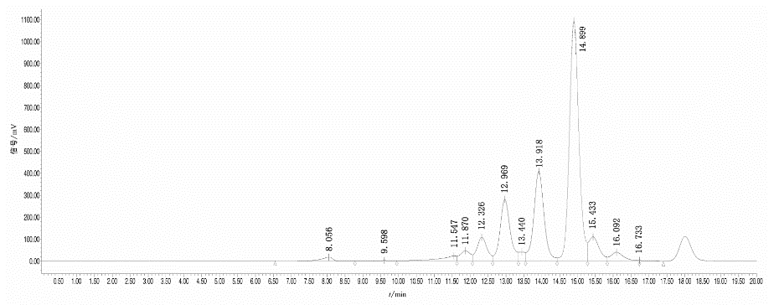

Note: 11.547min is xylohexaose and xyloheptaose, 11.870min is xylpentose, 12.326min is xylotetraose, 12.969min is xylotriose, 13.918min is xylobiose,14.899min is glucose, 15.433min is D-xylose, 16.092min is L-arabinose.

**Figure C.4 — Chromatogram of KS-802 sample solution after XOS-35 sugar powder enzymatic hydrolysis + alcohol precipitation**

______________________________